Macintosh HD:Users:le:Downloads:Screen Shot 2015-12-20 at 21.56.42.png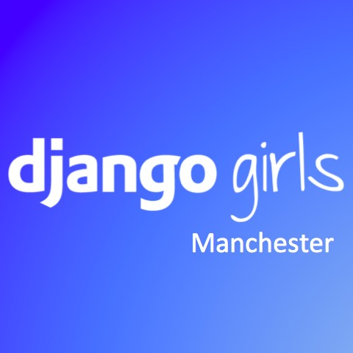

**Certificate of Mentoring**

**This certificate is awarded to**

**for mentoring the participants in**

**Django Girls Workshop,**

**Manchester**

**13th February 2016**

**Claire Dodd**

**Co-organiser**

**Leona So**

**Co-organiser**

Organised by:

Sponsored by: